**Lab Report**

**Wireshark Lab: HTTP**

学院： 计算机学院 班级： 07112002 学号： 1120200822 姓名： 郑子帆

**1. The Basic HTTP GET/response interaction**

1. Is your browser running HTTP version 1.0, 1.1, or 2? What version of HTTP is the server running?

Yes. It is running on HTTP version 1.1

1. What languages (if any) does your browser indicate that it can accept to the server?

Accept-Language: zh-CN,zh;q=0.9,en;q=0.8,en-GB;q=0.7,en-US;q=0.6\r\n

It can accept Chinese and English.

1. What is the IP address of your computer? What is the IP address of the gaia.cs.umass.edu server?

IP address of my computer: 192.168.1.102

IP address of the gaia.cs.umass.edu server: 128.119.245.12

1. What is the status code returned from the server to your browser?

200

1. When was the HTML file that you are retrieving last modified at the server?

Sun, 07 May 2023 08:23:34 GMT

1. How many bytes of content are being returned to your browser?

128

1. By inspecting the raw data in the packet content window, do you see any headers within the data that are not displayed in the packet-listing window? If so, name one.

No, I don’t.

**2. The HTTP CONDITIONAL GET/response interaction**

1. Inspect the contents of the first HTTP GET request from your browser to the server. Do you see an “IF-MODIFIED-SINCE” line in the HTTP GET?

No, I don’t.

1. Inspect the contents of the server response. Did the server explicitly return the contents of the file? How can you tell?

Yes.

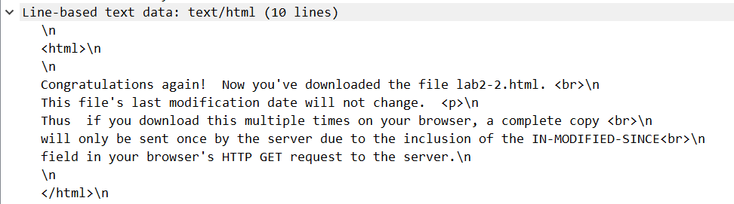

1. Now inspect the contents of the second HTTP GET request from your browser to the server. Do you see an “IF-MODIFIED-SINCE:” line in the HTTP GET? If so, what information follows the “IF-MODIFIED-SINCE:” header?

Yes.

If-Modified-Since: Sun, 07 May 2023 08:23:34 GMT \r\n

1. What is the HTTP status code and phrase returned from the server in response to this second HTTP GET? Did the server explicitly return the contents of the file? Explain.

HTTP status code: 304

Response Phrase: Not Modified

No, because the contents are already in the cache.

**3. Retrieving Long Documents**

1. How many HTTP GET request messages did your browser send? Which packet number in the trace contains the GET message for the Bill or Rights?

One. 8.

1. Which packet number in the trace contains the status code and phrase associated with the response to the HTTP GET request?

One. 14.

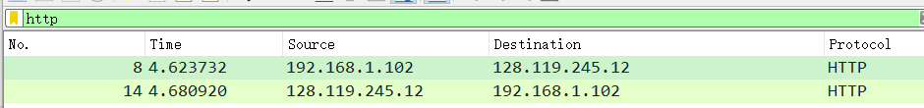

1. What is the status code and phrase in the response?

Status Code: 200

Response Phrase: OK

1. How many data-containing TCP segments were needed to carry the single HTTP response and the text of the Bill of Rights?

3.

**4. HTML Documents with Embedded Objects**

1. How many HTTP GET request messages did your browser send? To which Internet addresses were these GET requests sent?

3

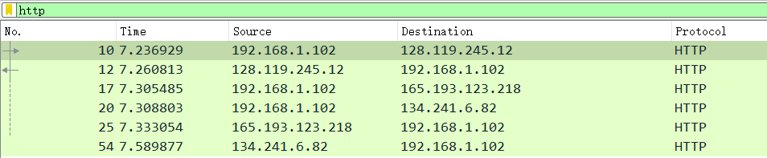

1. Can you tell whether your browser downloaded the two images serially, or whether they were downloaded from the two web sites in parallel? Explain.

My browser downloaded the two images serially, because the time is different.

**5 HTTP Authentication**

1. What is the server’s response (status code and phrase) in response to the initial HTTP GET message from your browser?

Status Code: 401

Response Phrase: Unauthorized

1. When your browser’s sends the HTTP GET message for the second time, what new field is included in the HTTP GET message?

Authorization.